Introduction
Welcome to the Majestic Apartments Newsletter.
I hope everyone has had an enjoyable year so far. We are hopeful that there are many more improvements we can make to your building in the coming months and years.
If anyone has any questions or queries, please do not hesitate to contact me at simon.perkin@realtymgt.co.uk or at the office on 0161 474 7677

Works Update
Lifts
The directors and Realty have met with the owner of the business Daniel Sheridan who is taking a keen interest in the lifts at Majestic and is currently appointing a nominated person to handle Majestic affairs, which will help with coordination of repairs and major works.. As a reminder, please report any issued with the lifts directly to Realty. For anyone becoming trapped in a lift please use the communication panel which will call the lift company direct.
Water Ingress
We recently wrote to you all with an update on the external façade works. Realty are continuing to source a larger, reputable builder who has the relevant experience and competence to perform what we need. With many builders extremely busy in the winter months this is taking some time to get them down to the site to survey the proposed works. We are aware that a further meeting needs to take place once we have received costs from the builder. We expect this may now need to take place early in the new year. If we can accelerate this, we will write to you all once again.
Fire Safety
After much discussion with the freeholder’s agent Simarc, it is evident the Landlord may not be liable for the fire safety issues in the block as the limit of liability is only 30 years. To this end, Realty will be applying to the government’s new mid-rise cladding fund to secure funds to replace the cladding over the rear stairwells.
Additionally the works to fire stopping the service cupboards and garage is being instructed and we are hopeful to start this work before Christmas. We will write further with confirmed dates and any actions required for our leaseholders.
Further communication on the fire doors – communal and flat entrance – will be delivered once the latest Fire Risk Assessment is received.

Landscaping
We would like to thank the gardening group for all their efforts. Additionally our new gardeners have received glowing report from the group and others.

Resident Contractors
Could all residents remind their private contractors to sign the visitors’ book. This is kept on the wall of the lift lobby of block C, in the basement.

Balcony Balustrades
Following reports form resident that they are concerned over the strength of their balustrades, we have approached two companies who can perform strength tests however the costs coming back were in the region of £8,500 to £12,000, which the board deemed uneconomical given the upcoming works to the external facade. Therefore, we would request that anyone with concerns raise them directly with Realty.

Notice Boards
The notice boards in the garage will be updated with additional documents pertaining to fire safety and general management of the building.

Garage Door Access
May we remind all residents to ensure the garage doors are fully closed before driving away. There has been a recent incident of theft of some bicycles, where we believe the perpetrators entered under a garage door.
Could we also ask residents to wipe the sensors of the doors periodically. Such is the nature of the location of Majestic, sand is often found clinging to the sensors preventing the doors from closing properly.

Building Access
Please do not allow anyone in to the building unless they are known to you. We have received several reports of persons found in the communal areas after being let in via the intercom with no verification of who they are.

British Heart Foundation Red Bin
This has been removed due to it being used inappropriately (rubbish and unsuitable items being placed in it). Please can owners refrain from leaving items where the bin used to be and take items to a local charity shop. See example of dumped items:
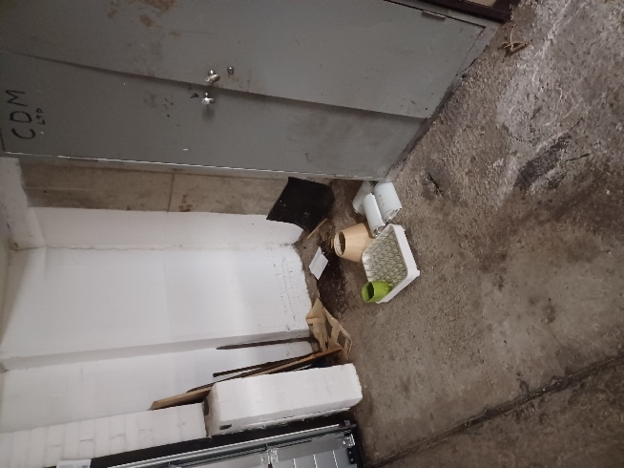

Reporting of Maintenance Issues
We would like to inform all owners of the correct procedure for reporting all maintenance issues, which is to report directly to Realty via phone 0161 4747 7677 or info@realtymgt.co.uk

Resident Fire Strategy
The following details the procedure all residents should follow in the event of a fire:

IF FIRE BREAKS OUT IN YOUR HOME:
Leave the room where the fire is straight away, then close the door.
Tell everyone in your home and get them to leave. Close the front door of your flat behind you.

Do not stay behind to put out the fire.
Call the fire service.
Wait outside, away from the building, on the car park.

IF YOU SEE OR HEAR OF A FIRE IN ANOTHER PART OF THE BUILDING:
Specialist risk assessors have advised that the building is designed to contain a fire in the flat where it starts. This means it will usually be safe for you to stay in your own flat if the fire is elsewhere.

You must leave IMMEDIATELY if smoke or heat affects your home, or if you are told to by the fire service.

If you are in any doubt, get out.

TO CALL THE FIRE SERVICE:
Dial 999.
When the operator answers, give your telephone number, and ask for FIRE.
When the fire service reply, give the address where the fire is.
Do not end the call until the fire service has repeated the address correctly.

Basement Storage
We would like to remind residents of the regulations on the storing of items in the basement:
- Standard storage in any car parking space to be restricted to one correctly taxed/MOT’d/insured motor vehicle, and/or motorcycles, mopeds, bicycles, or Motability scooters.

- Additional items which would be acceptable include wheelchairs and mobility aids, and non-combustible items such as metal step ladders etc. This list is not intended to be exhaustive and residents in any doubt should approach the managing agent for further advice on specific items.

- All other items – timber, cardboard etc. if stored in the car parking area must be safely stored within a closed and locked metal cabinet intended for storage purposes – plastic or wooden cabinets and enclosures are not permitted.

- Electrical appliances such as fridges, freezers etc are not permitted.

- Any storage must be within the marked confines of the owners parking space and must not be allowed to spill over into any other area.

- As recommended by the Lancashire Fire & Rescue Service, all vents within the garage area must be clear and unobstructed, both for the clearance of smoke in the event of fire but also to allow ventilation for exhaust fumes.

Directors
The current list of directors is as follows:

Block A
Tony Berwick

Block B
Martin Chatfield
Sue Blackburn

Block C
Denis Lees
Doreen Thomas

Block D
Eric Brown
Richard Hyde

